**DCE Toolbox**

Designed for the analysis of DCE data, based on Tofts et al. (Tofts and Kermode, 1991).

The software package includes:

* DUSTER: DCE Up-Sampled Temporal Resolution Analysis Method - A proposed method for improving the extraction of AIF and PK parameters and estimates the BAT parameter (BAT ref).

Current Stable Version : DUSTER V2.6

* DCE Perfusion Analysis Method - For perfusion calculation from DCE data, incorporating the delay estimation allows to visualize another important parameter (Guys Ref).

**Installation**

**Requirements**

Operating system: Was tested on Microsoft Windows 7 and LINUX

System requirements: Matlab 8 + SPM8

**Software Installation**

Download the "Code" and "Tools" folders.

In Matlab, add the SPM8 and the code and the Tools path:

Matlab->File->Set Path...->Add with subdirectories->

**Data Import and Analysis Configuration**

Data Structure

DCE - All image files that form a data set for analysis should be located in a single directory.

The mandatory folders are: the dynamic data must be in a single series, and at least one series with different flip angels from the dynamic data.

DSC - The mandatory folders are: the dynamic data must be in a single series

**Team members:**

Head of the group: Dr. Dafna Ben Bashat: [dafnab@tlvmc.gov.il](mailto:dafnab@tlvmc.gov.il)

Main code written by: Dr. Gilad Liberman: [giladliberman@gmail.com](mailto:giladliberman@gmail.com)

Application and development: Moran Artzi: [artzimy@gmail.com](mailto:artzimy@gmail.com)

Development of the DCE Perfusion Analysis cod: Guy Nadav: [guyov1@gmail.com](mailto:guyov1@gmail.com)

**Advanced DCE GUI Options**

**\\FMRI-GUY2\SourceForge\Stable_Versions\code\Version_2.6**

GUI Activation:

Activate Matlab and type:

cd \\fmri-guy2\Dropbox\University\Msc\Thesis\SourceForge\Stable_Versions\code\Version_2.6

DCEInit

setComputerParamM('temppath','D:\Temp\')

dbstop if error

MainGUI

To forget stuff that auto-loads into MainGUI

delete([fileparts(getComputerParams('infosfn')) filesep 'LastMainGUI.mat'])

**DCE Maps**

**>>DCE maps:**

**Ktrans** - map of the transfer coefficient of concentration between the bloood plasma and extravascular extracellular space (EES) given in 1/min.

**Ve** - map of total EES volume. Given in arbitrary units (0-1).

**Vp** - map of otal blood plasma volume. Given in arbitrary units (0-1).

**Kep** - map of the rate of consentaion ("Invers premability" - What returns blood vessels). given in 1/min.

**BAT** - map of bolus arrival time Ve. Given in secounds.

**RMS** - map of root mean squareerror map per voxel relative to the AIF

**rRMS3D and RMStoNoise** - normelized RMS maps

**>>Relaxometry folder:**

**T13DOFA** - T1 map

**PD3DOFA** - PD map

**RMS3DOFA** - RMS of relaxometry map

**Main GUI**

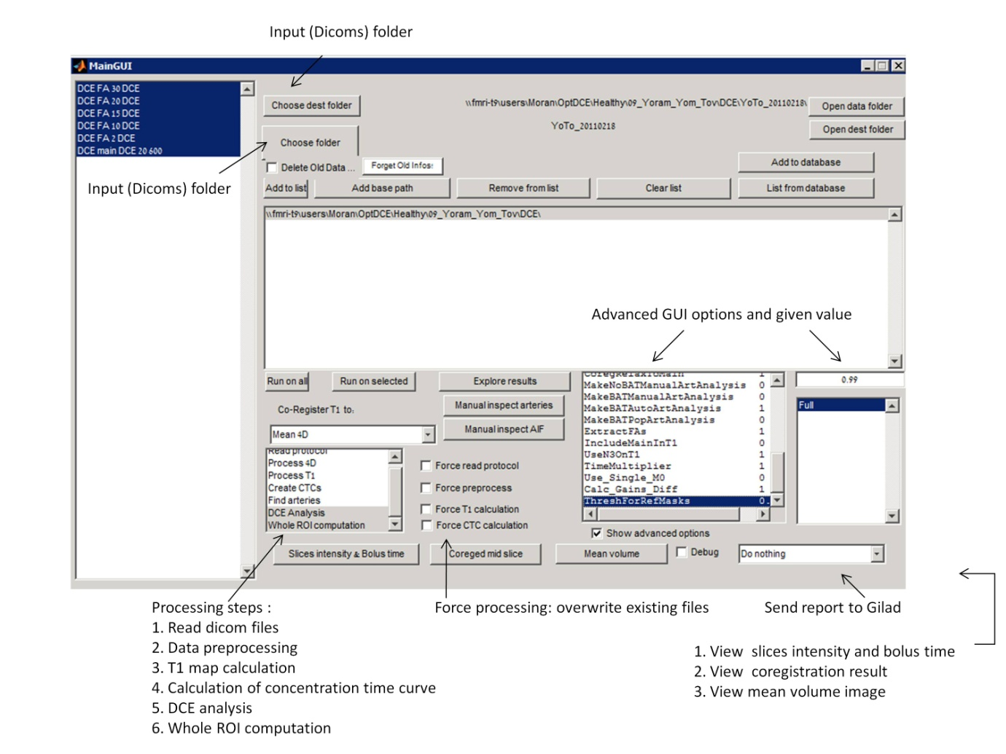

**Explore Results GUI**

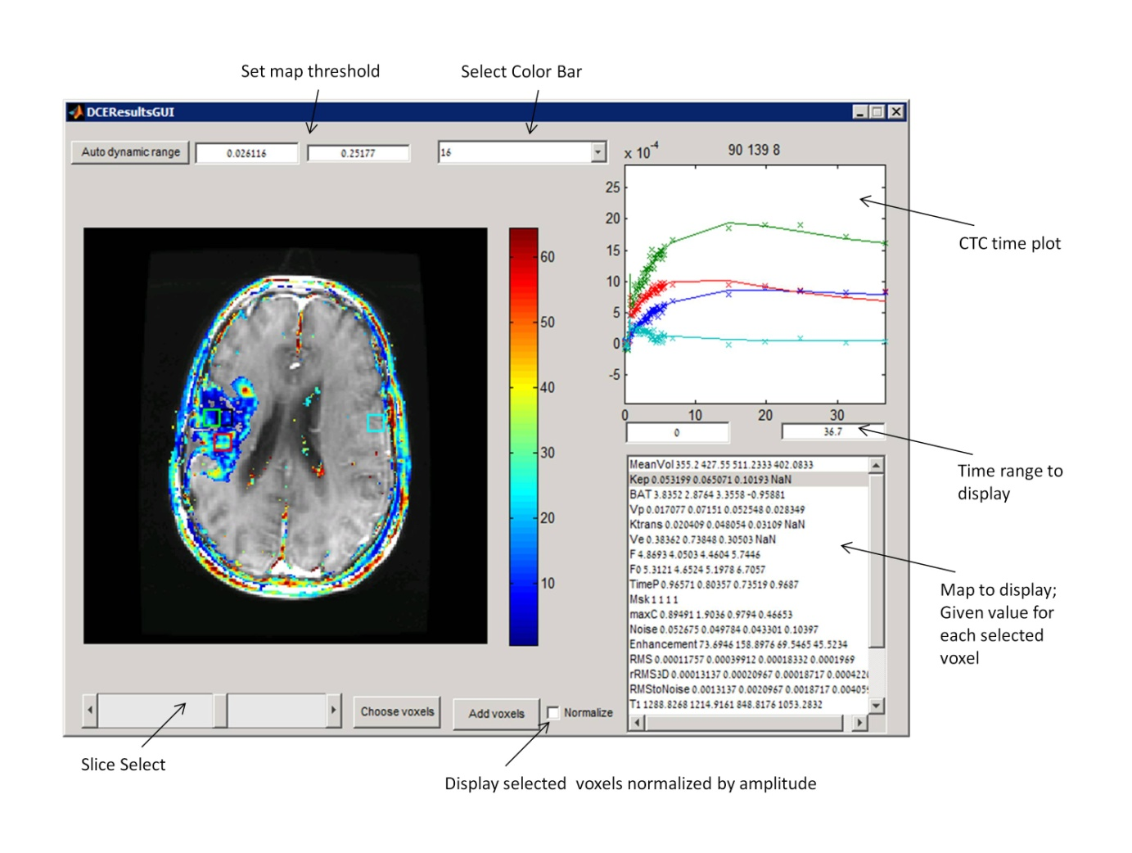

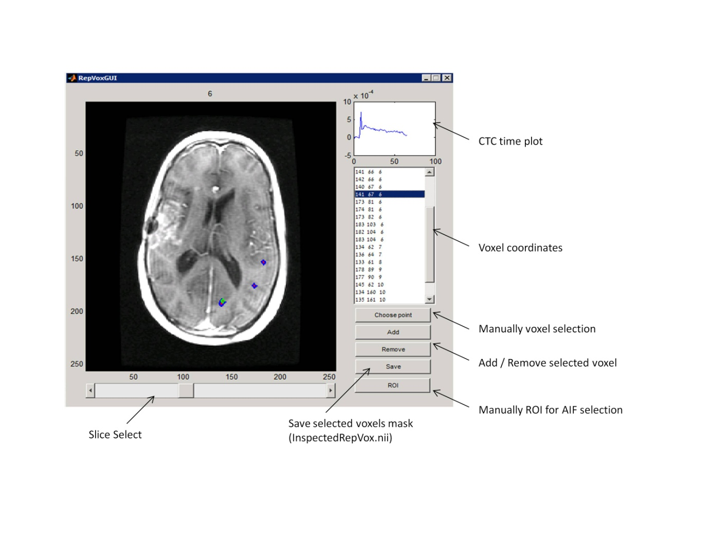**Manual Inspect Arteries GUI**

**Manual Inspect AIF GUI**

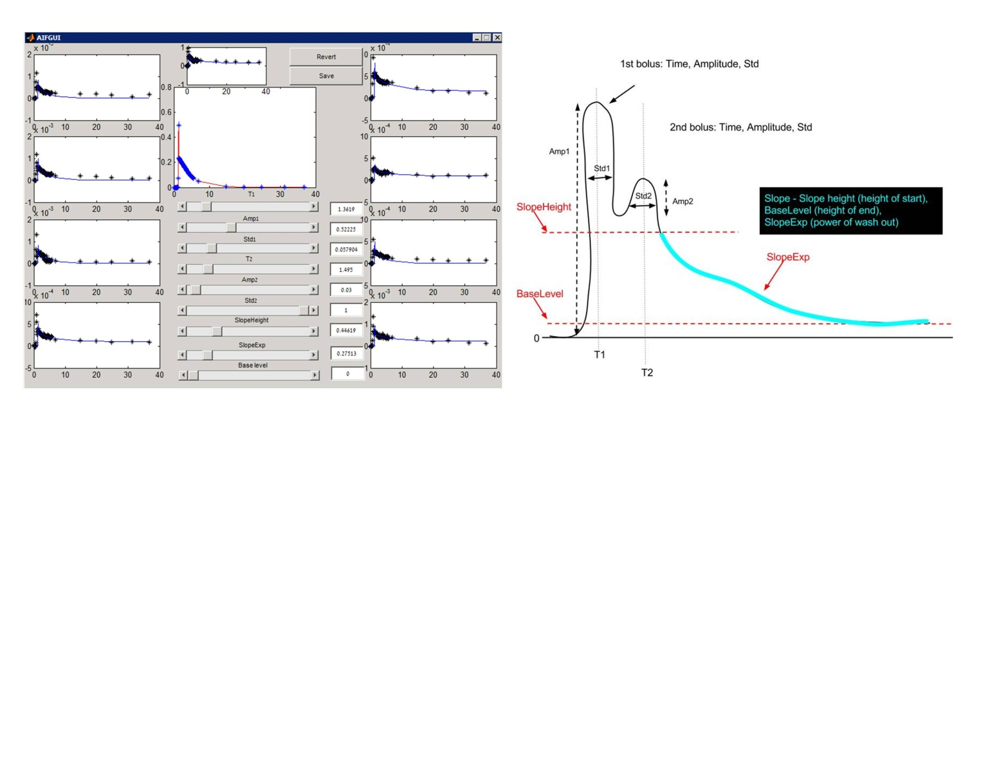

**Advanced DCE GUI options**

1. **SubSampling** – Allowing to sub-sample the original data (use lower temporal resolution)

Default: 1. DO NOT CHANGE (used for high resolution data). 3= for HTR change from 2sec to 6sec

1. **nVolsToRemoveFromEnd** - Cut the last volumes of the test (sometimes the last volumes are distorted). Default: 0
2. **SubSecondResolution** - Number of sub seconds parts for super resolution ("2" means 1/2 of a second). Default: 2
3. **MinFirstBolusStd** - The minimum width of the bolus (standard deviation of the Gaussian that represents the first bolus). Default: 2
4. **EM_Num_Of_Iterations** - Number of iterations for the Expected Minimization algorithm which finds the optimal AIF and parameters. ). Default: 5. (Currently not used).
5. **FMS_TolFun** - Function Minimum Search's (Matlab's) parameter. Tolerate Function – minimal improvement for continuing the search. Default: $e^{-11}$
6. **FMS_MaxFunEvals** – Number of possibilities for the F Mean Search at each step to change. Can think of it as in the case of 2-D vector f(**X**) ( How many 2-D points to move to from the current one). Default: 10000
7. **FMS_MaxIter** - Maximal Number of iterations for FMS algorithm. Default: 10000
8. **MaxTDif_ForAIFSearch** - The possible shift in time for the AIF of the representing voxels (in seconds). Default: 3
9. **MaxTDif_ForWholeVOI** - Same as MaxTDif_ForAIFSearch, just when allowing shifting in time for all voxels in VOI (and not just representing voxels). Default: 6
10. **Rep_MaxAroundBolus** - Number of clusters around the bolus (for finding representing voxels). Default: 10
11. **Rep_RatioToEnd** - Number of clusters around the end of the test (for finding representing voxels). Default: 10
12. **Rep_nPerSet** - Number of total clusters will be MaxAroundBolus *Rep_RatioToEnd. This option will determine how many representing voxels we will choose from each cluster. Default: 1
13. **Mask_Thresh** -Set threshold for masking (the general mask of where to work).

For positive values (0-1) uses SPM for masking.

For negative values (0 to -1) uses BET for masking.

The absolute value is passed to the SPM or BET.

Default: 0.5 (i.e., positive, uses SPM and the thresholds with 0.5).

1. **Run_On_All** - Run all processing steps. Default: 0(Currently not used).
2. **TimeDelayToMaskVeins** – Delay from Bolus peak. Default: -0.5
3. **WeightForAIFMeanVesses** –Similarity to the selected AIF Default: 0?
4. **MainCoregistration** - Choose between 1-realignment, 0-no motion correction and >=2 – coregister to that volume. Default: 1
5. **CoregRelaxToMain** - Do coregistration between Relaxometry and main. Default: 1
6. **MakeNoBATManualArtAnalysis** – If "1" and manualArt.nii exists, take the arteries from that file, take their average and make a regular calculation (we have AIF so we simply use Murase to get the PK parameters) without the possibility to shift BAT. Default: 0
7. **MakeBATManualArtAnalysis** - If "1" and manualArt.nii exists, take the arteries from that file, calculate the parameters using F Min Search on the picked arteries (instead of finding representative) and allow the possibility to shift BAT. Default: 0 (Currently not used).
8. **MakeBATAutoArtAnalysis** – The default mode of choosing the arteries automatically. Default: 1
9. **Extracted FAs** - Correct the flip angles of the scan (we assume there is an error).Default: 1 (Currently not used).
10. **IncludingMainInT1** - Default: 1. Include the DCE main (FA 20) in T1 calculation. (DO only if the DCE main acquired with the same calibration as the DESPOTs)
11. **UsingN3T1** -Do inhomogeneity correction. Default: 1
12. **TimeMultiplier** - Default: 1
13. **Use_Single_M0** -Enable calculating T1 using a single angel.Default: 0
14. **Calc_Gains_Diff** -Enable/disable gains calculation made by Gilad. Default: 1
15. **ThreshForRefMask.** Default: 0.99 – threshold for the segmented WM mask (used as reference for T1 and Vp cakculation).

**Relaxometry coregistration - Use the list box:**

Can coregister to DCEMean ('Mean 4D'), use no coregistration (' No coreg’) or coregister to the median angle. Anyway will coregister the T1 map o DCE mean.

**To force AIF shape (parameters) calculated before:**

InspectedAIFParams.mat

**To add reference files insert NIFTI files named:**

RefVp_WM_830.nii

RefT1_WM_830.nii

Manual_BrainMask.nii

**For artery selection:**

InspectedRepVox.nii - Takes exactly what's there, or

ManualArtMask.nii- Looks for arteries only inside that mask.

**Supplementary scripts:**

1. **Fast Vp:**

Run FastVpMap.m script (after changing into the subject output folder )

Make maximum in the bolus area and extract FastVp.nii map into the subject AutoArtBAT folder

2. **Compare between Ewing and Sourbron's normalization:**

Run NormalizeByVeinsN.m script

Takes the Veins AUC and normalize to it

Gives figure with Jims normalization in blue and Sourbron normalization in Red and Magenta.

(The new normalization factor appears in the title)

>> Required input:

* Veins.nii binary mask with selected veins
* DCE output folder

>> Changing into the subject output folder

>> Set the Percent

**3. RUN ICA for AIF selection**

Run CTC_ica.m script

**DCE – Perfusion [Guy]**

**\\FMRI-GUY2\SourceForge\Stable_Versions\code\Version_2.6\Code\DCE_Perfusion**

Run ReadRealData.m script

>> Change the Red fields

Subject_name  = 'ReYe';

Subject_Path  = '\\fmri-t9\users\Moran\DCE\HTR_STROKE\01_REMEZ_YECHEZKEL\Study20140615_114415';

WM_mask_absolute_path = [Subject_Path  '\RefAuto1_WM_830.nii'];

Art_Mask  = [Subject_Path  '\ManualArtMask.nii'];

After_CTC_mat   = [Subject_Path  '\AfterCTC.mat'];

%DCECoregP = [WorkingP 'DCEMainCoreged' filesep];

% \\fmri-t9\users\Moran\DCE\HTR_STROKE\01_REMEZ_YECHEZKEL

DCECoregP = [Subject_Path filesep 'DCE_out' filesep 'OrZe_20130811' filesep];

DCECoregP = '\\fmri-t9\users\Moran\DCE\HTR_STROKE\01_REMEZ_YECHEZKEL\';

**Include Bat Concoction**

In Simulation_Set_Params.m script, Set:

Sim_Struct.AIF_delay_low = 0;   -> -1

Sim_Struct.AIF_delay_max  = 3;   ->  20 (in stroke)

Sim_Struct.Upsampling_resolution  = 0.1 / 60; % Set the upsampling target   -> 0.5/60

Sim_Struct.Correct_estimation_due_to_delay  = true;   % Try to correct for delay

**Perfusion_DCE – output names**

<< to be added >>

**DSC - Perfusion [Chen]**

\\FMRI-GUY2\SourceForge\Stable_Versions\code\Version_2.6\Code\DSC

GUI Activation:

Activate Matlab and type:

DSCMainGUI

Click on **Init** button on the main Gui